# Louis Cha’s Wuxia Map

——<https://orangantzhang.github.io/final/wuxia_map.html>

1. Introduction

Nowadays, there are abundant Chinese costume dramas series attracting audiences for entertainment in which wuxia elements like fighting scenes are essential Chinese features. Classic wuxia novels like Louis Cha’s work are pressure resources which have been adapted for various editions and still in 2020. Also because of so many editions of Louis Cha’s series work that every time a new version is released, it will always trigger netizens enthusiastically comparing plots, actors and so on that launch various discussions. We can see Louis Cha’s work are still classic nowadays. For many people, they will inevitably mention the information of novels when discussing, and they need to have a basic grasp of novels.

There has been a website like Jinyongwang.com, that comprehensively introduces Louis Cha’s works, such as providing online reading resources and introducing characters in each novel. This website is more like a resource-based website for users to get access to novel contents.

However, when I conducted an interview survey with seven 20-25 years old respondents and I found they considered Jinyongwang.com boring because they usually knew about Louis Cha’s work just for relaxation and did not want to spend much time reading and deep learning. They need to get a basic but quick understanding of each work and also want knowledge interesting. Then I realize there actually exists a huge popularity that is the potential enthusiast of Louis Cha’s wuxia work. How to meet the requirements of getting interesting relevant information, I came up with integrating wuxia maps into the website. Because I found that my respondents all plan about two trips a year, and the choice of places to travel can be affected by many factors. For example, this place is popular on the internet and has some legends and so on, which fits the situation of Louis Cha’s wuxia novels. Even audience do not travel to these places, this map element can increase the interest of my website, meeting potential fans’ need. With this consideration, I want to dig deep their existing needs and solve their problems.

1. Requirement

In this part of the report, the target users of the site are interviewed to create a basic customer journey map, summarize the problems as pain points they may have been encountered on their journey to obtain Louis Cha’s information, and develop a problem statement based on this. In response to this problem statement and related pain points, the objectives of this site will be illustrated.

2.1 Current problem and support

Targeted at potential enthusiastic of Louis Cha’s works, I interviewed 7 students about the problems they encountered when know about Louis Cha’s information and got a basic customer journey map:



Customer journey map

The pain points of target users can be concluded initially as follows:

At the stage of generating interest, potential audience usually get interest in Louis Cha’s works on video platform when watching related series or on social media platforms when read some information. However, website like Jinyongwang.com is too boring for them. And the main painpoint of potential fans is feeling bored through only reading novel contents to know about wuxia.

After they generate some interests in Louis Cha’s work, they would like to find more information. But audiences usually find related introductions of works are too broad and complicated to get a basic knowledge like Jinyongwang.com that cannot make users get a quick grasp of information. Furthermore, when they browse on different platforms, they usually think information is too scattered and they can easily encounter much fake information. Because these are too many rewritten novel contents by others and use the same titles with Louis Cha. For potential fans, they are not qualified to identify the authenticity of information. The searching process is too time consuming.

When deep learning Louis Cha’s works, they are confused to decide the reading order of novels and also feel hard to decide which edition is worth choosing.

According to communicating with others, potential fans need some correct and professional feedbacks when they have some questions about Louis Cha’s works.

With regard to travelling map element, I further interviewed respondents and found they would like to know a list of related tourism viewpoints with descriptions in novels. Go further, they want to know about local tourists’ comments and recommendations which can provide them more interests in these sites. There are many travel websites like alitrip.com, mafengwo.com (马蜂窝) aggregating multiple functions from travelling guideline to booking. And when talking with 7 respondents, they all think my website do not need too many functions about travelling that they mostly want to know about these places and corresponding novel plots from my website. This feature is relatively blank in all current websites.

2.2 Need

With the above discussion, the user needs can be summarized. The target users (potential fans of Louis Cha’s works) need a website that can provide a basic, concise but relatively comprehensive overview of Louis Cha’s works from novel summary, rating, recommended reading order, main characters to locations where the storyline happened, tourist evaluations and so on. They need a quick searching experience and also interesting information.

2.3 Objectives

Considering the pain points and user needs concluded above, the problem statement is that how can my website help potential fans of Louis Cha’s work quickly get a basic knowledge of all his work and generate further interests in deep exploring novel contents or Tv series and travelling to these places.

The objectives of this website to be built are: providing a brief but interesting introduction of Louis Cha’s works; building a comprehensive travel map about Louis Cha’s novels and find out related novel contents; giving reasonable navigation and sorting methods that cater for diverse needs such as reading order, locations (province, city); providing more visual elements like pictures, videos, charts to present information in a structured, clear and beautiful way.

1. Data gathering

This part has two main section—— content requirement based on previous interview feedbacks and data flow diagram. Firstly, the content requirements are shown in the table below.



Introduction video is from Youtube.com. Novel related contents and images are mainly from Jinyongwang.com and other online googled results. Ratings of each novel are from Douban. Locations in wuxia map section are from 163.com(网易) survey results and interviews with a professional teacher. Tourist evaluations are mainly from mafengwo.com(马蜂窝), a tourism website.

Given the above key contents, the data flow of this website is illustrated below.

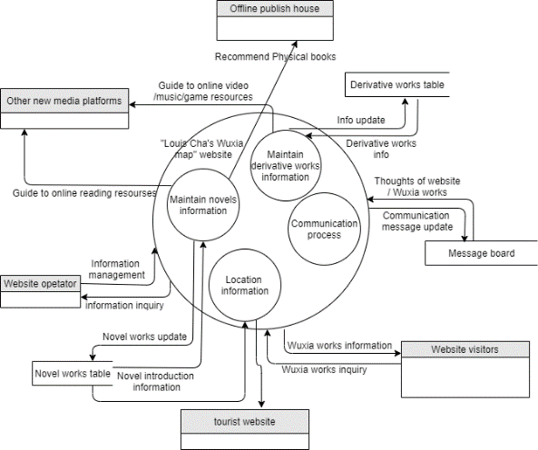

Data flow

1. Design
   1. Usability test on competitor

Because this website has 2 main part——Louis Cha’s wuxia works and wuxia map. Therefore, it is hard to find a very similar competitor. Considering that I have conducted previous interview survey with 7 respondents on Jinyongwang.com, this time I select alitrip.com as a competitor to conduct a usability test on wuxia map section. I set up the test goal is finding a location as your next travel destination.   
In terms of effectiveness, the completion rate of 5 participants is 100%.  
The efficiency is shown in the table below.



Usability test-time cost

In general, 5 users all think the whole process is a little bit complex because there are too many functions and commercial service contents on the website and it’s hard to find detailed information which they really need.

First of all, the user interface is a little bit messy for people to find the tourism destination and participants only use the search box. However, after typing in one location in the search box, the results are a list of travel service packages and there is no introduction of attractions. At the bottom banner, some people can find an icon called destination, when they go in the destination page, there is no option of sort by Chinese regions. It only provides some popular tourism cities for users to pick. But for someone who wants to explore new tourism places which they forget names, it can be a difficult thing. In this page, there also exists a search box. Users can type in one city and find the introduction and guideline contents of this location. Alitrip.com is too confused and time consuming in the usage. Some people think pictures are not attracting to them. After combining their need in basic knowledge of Louis Cha’s work. I designed a low friendly prototype. And further conducted a usability test.

4.2 Low-friendly prototype

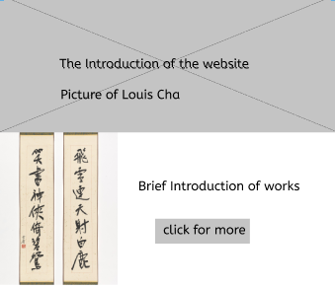

Homepage

When click “click for more” button, it shows introduction of each novel part.

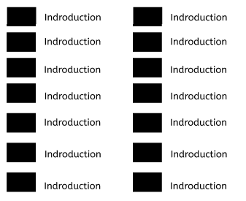

Introduction

When scrolling down, it appears a map, on which there exist points of plots and people can click to other pages show plot details and location introductions.

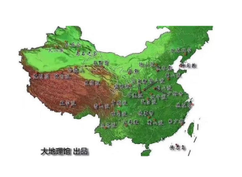

Map

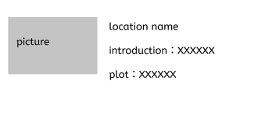

Location introduction

For this prototype on Figma, a usability test is also conducted. I ask participants to freely browse the website and find what they desire for my website. Based on their suggestions, I make further adjustments and develop a high-fidelity prototype below.

4.3 High-friendly prototype

The first adjustment is about adding navigations——homepage, introduction of works, locations tourist evaluation and login. I use a banner image with concise words “Louis Cha’s tourism map” to introduce my website’s main feature.

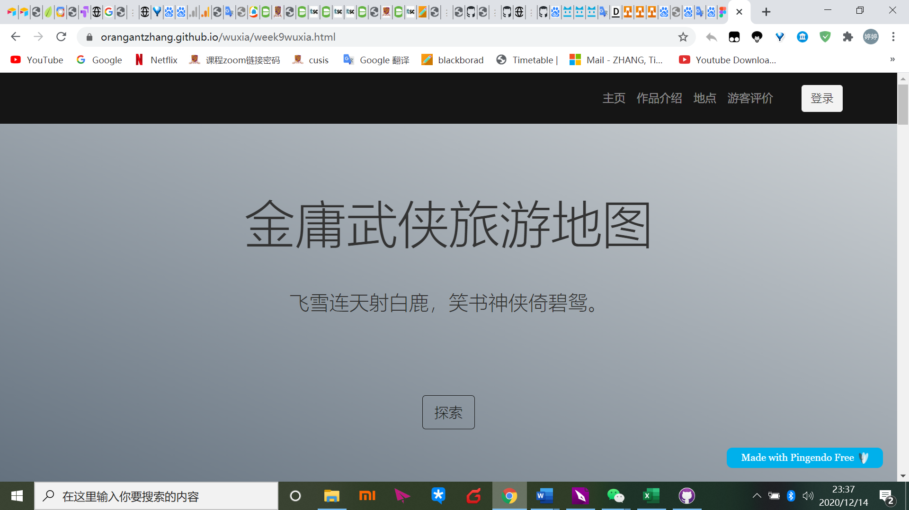

Homepage

One participant considers in the previous Figma to know about Louis Cha’s work is boring. Therefore, I use one famous sentence to introduce one novel which can give users a brief knowledge of this book. Furthermore, I add a video——a fast learning and interesting method for potential users because the video contains different versions clips of almost 15 Louis Cha’s work in 6minutes.

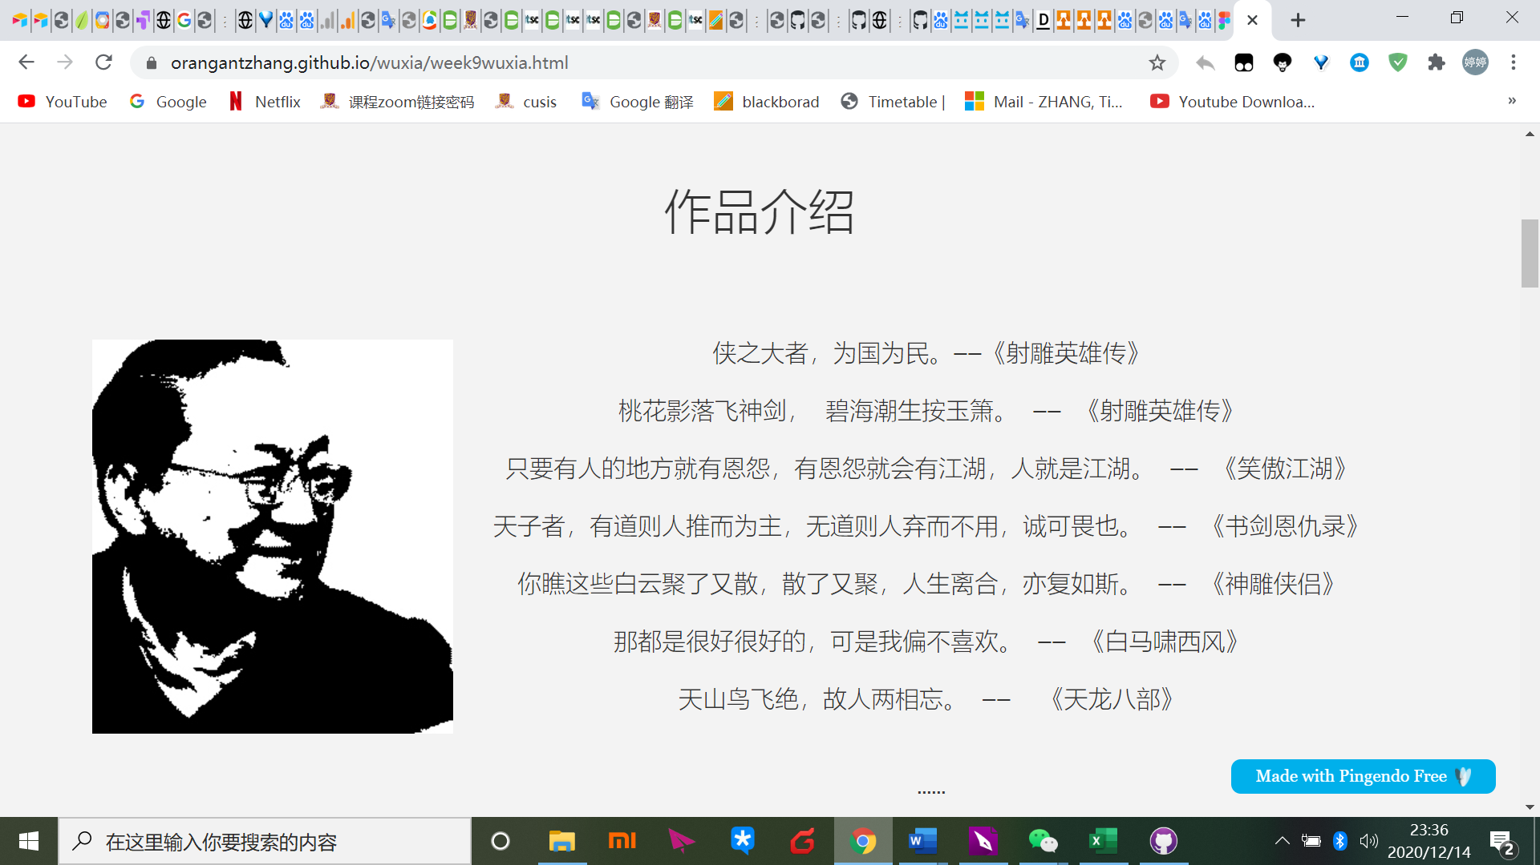

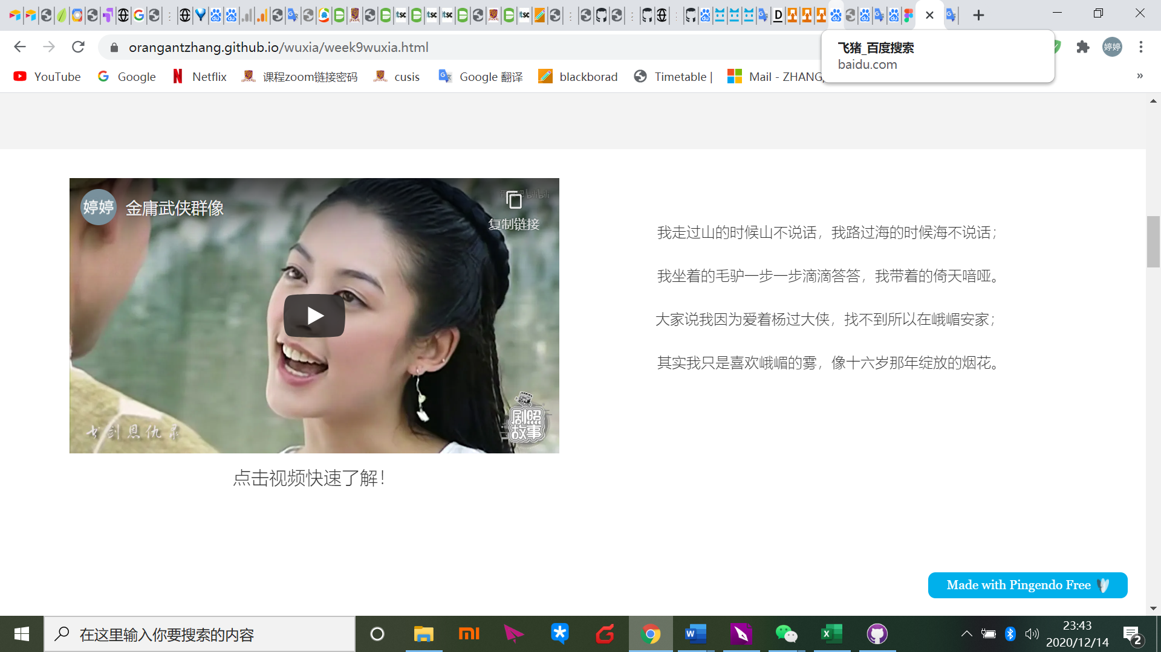

Introduction of works

Scrolling down, users can find more introduction of each novel. I also provide a sort here that users can know about novels by ratings or by numbers of words which is useful for them to decide reading order and know about the quality of each work.

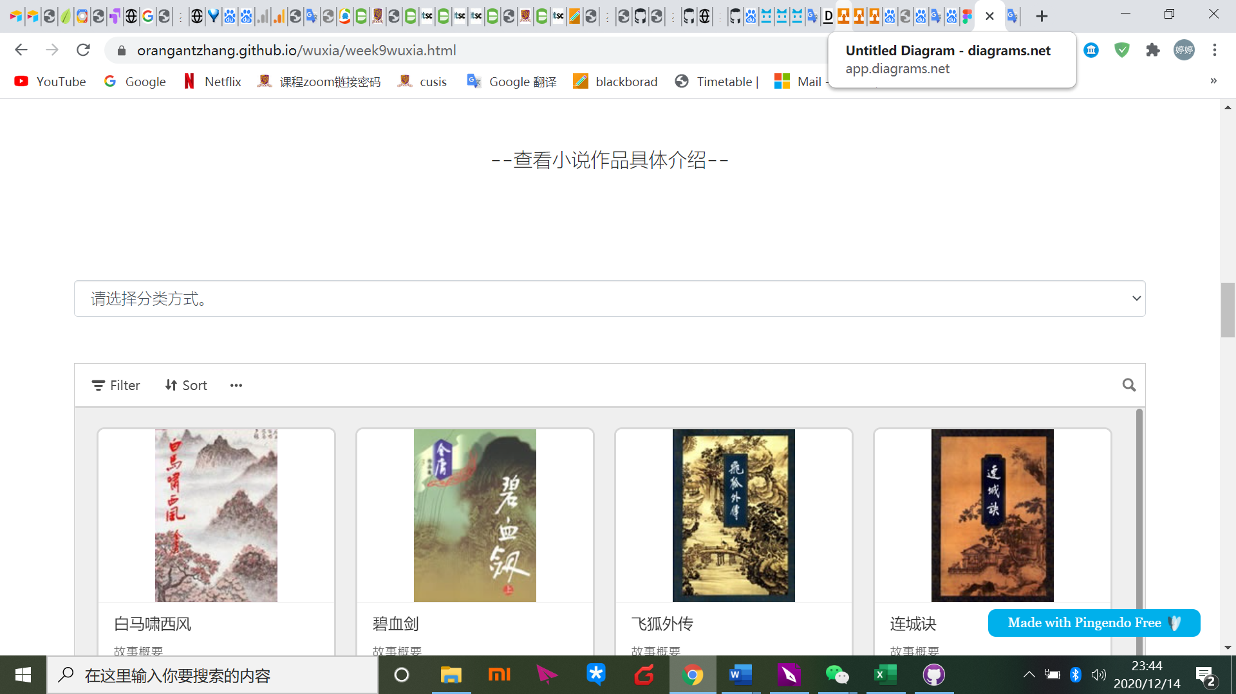

Introduction of each novel

Next, it comes to the location part. Users can clearly find eight areas, which they can click for detailed information—ticket information, local cuisine, recommendation rating and introduction. Test users think these are important factors affecting them to tour.

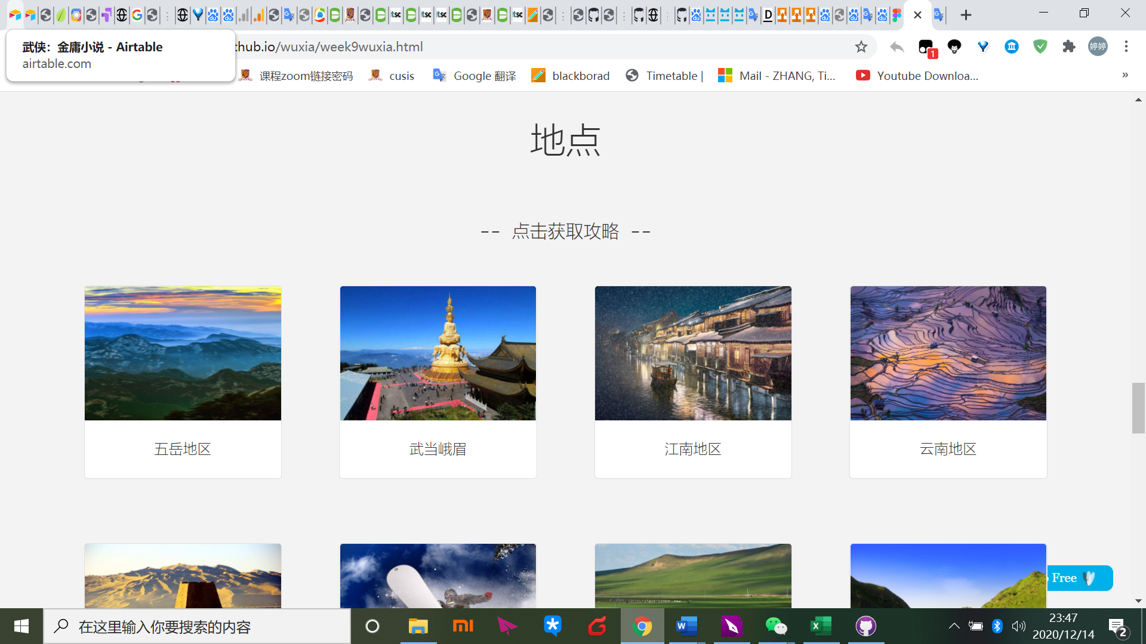

Location

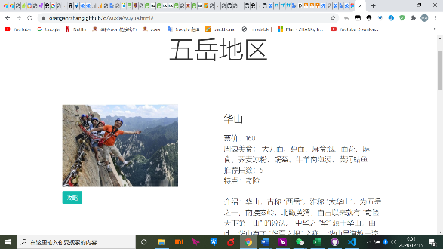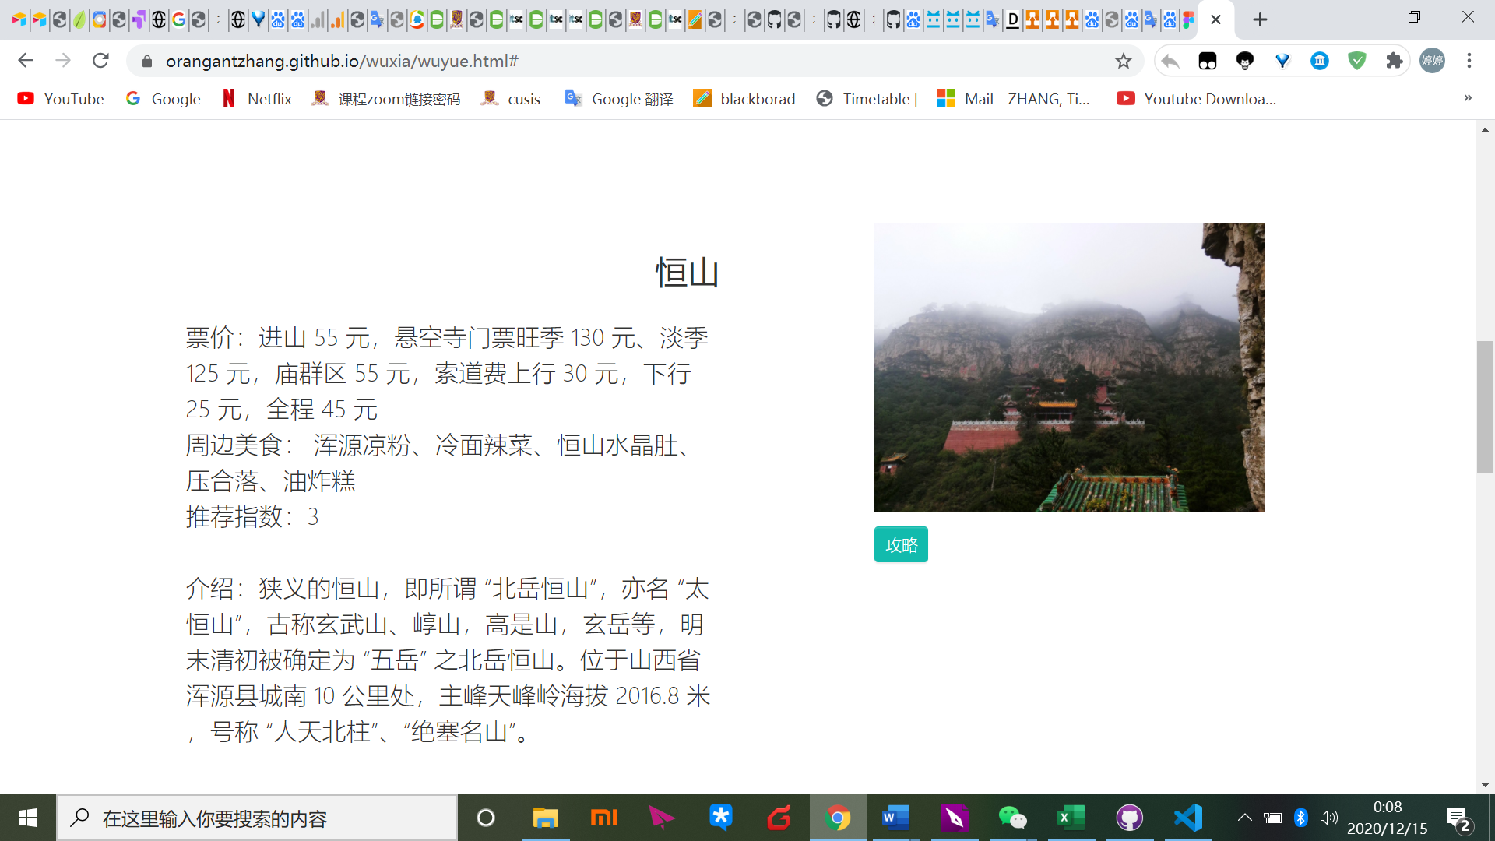

Details of locations

Consistent with classification in the area section, all locations are shown in airtable sorted by these eight areas to mainly present plots in original novels. The location is put in the first column also with geographic information (province, city), which is straightforward for users to know the destination in our real life. Apart from corresponding plots and novels, the site also provides a recapitulative recap of the plot(大事记) to make potential fans get a brief acknowledgment of the plot and then decide whether to read or not.

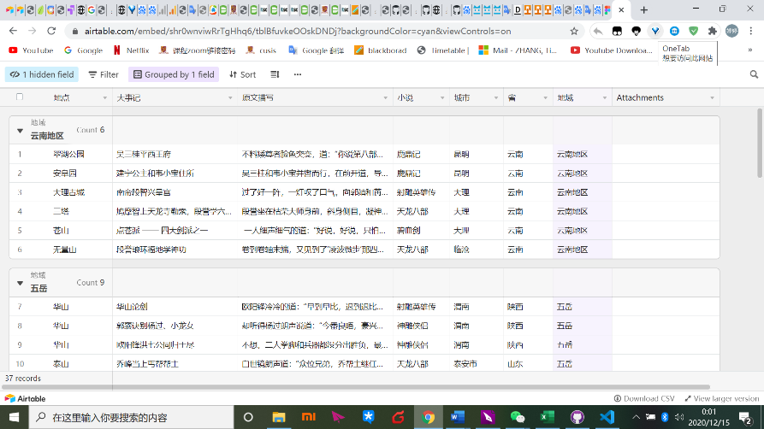

Location-Plot

For test users who would like to travel to these places, they want up-to-date tourist evaluations. This site collects 2019-2020year evaluations from mafengwo.com and balances both good evaluations and bad evaluations. In the evaluation section of the table, users can unfold boxes to know more about this travelling experience like how they prepare for this tour and what tourists should pay attention to.

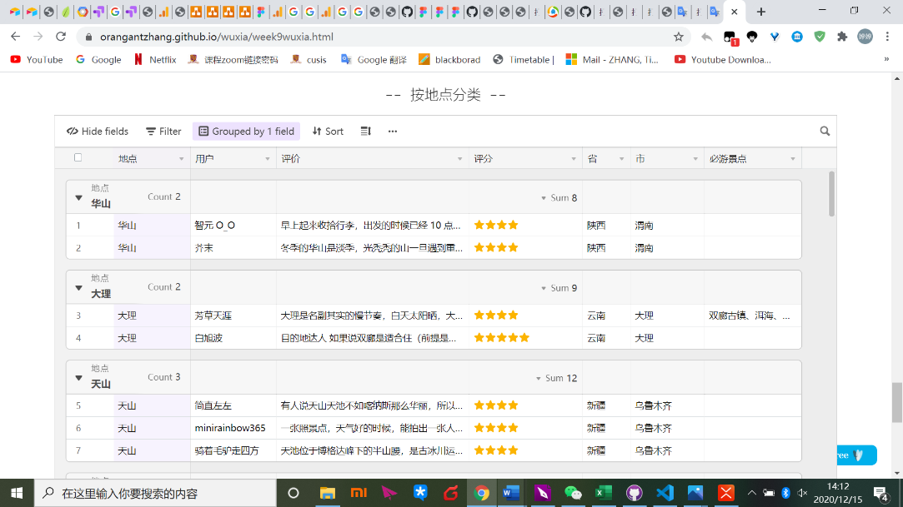

Tourist evaluation

1. Test and evaluation
   1. Usability test on high-friendly prototype

The third usability test is conducted for the high-friendly prototype, making users to freely browse the website and find what they desire from my website (the same task with the second one). And results show as follows.

1. Making the banner more attracting and changing website name

Respondents think the previous banner is not satisfied. Also the website name is transferred from 金庸武侠旅游地图to金庸武侠地图.Because it does not have too many features that travel websites should have. Also not all users have the travel need that “travel” keyword may discourage them to browse.

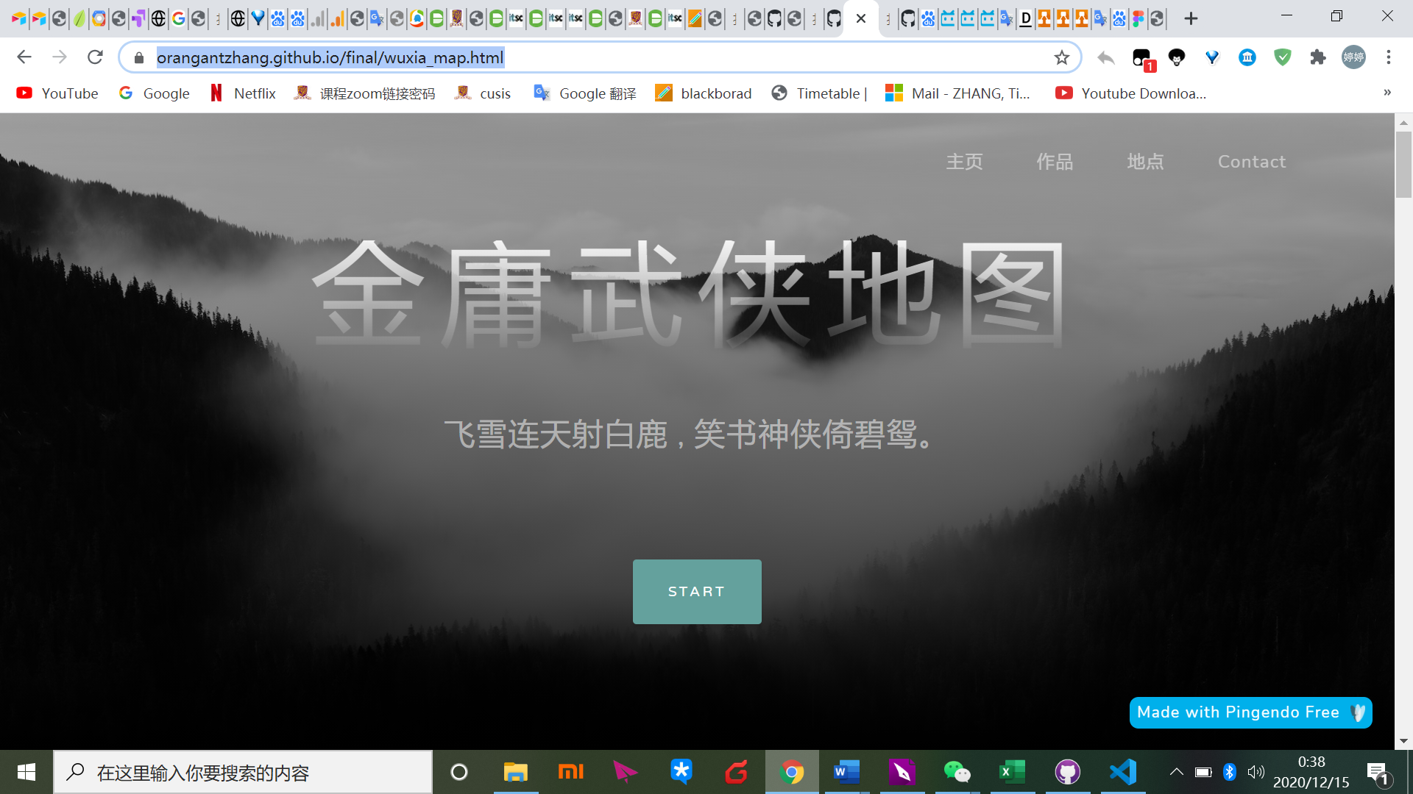

Homepage

1. Adding more pictures of Louis Cha’s works

Previous picture in the introduction part is one Louis Cha’s image and respondents think if there are more visual information, this part is more interesting. Therefore, it uses carousel format to present not only Louis Cha’s photo but also some classic series stills.

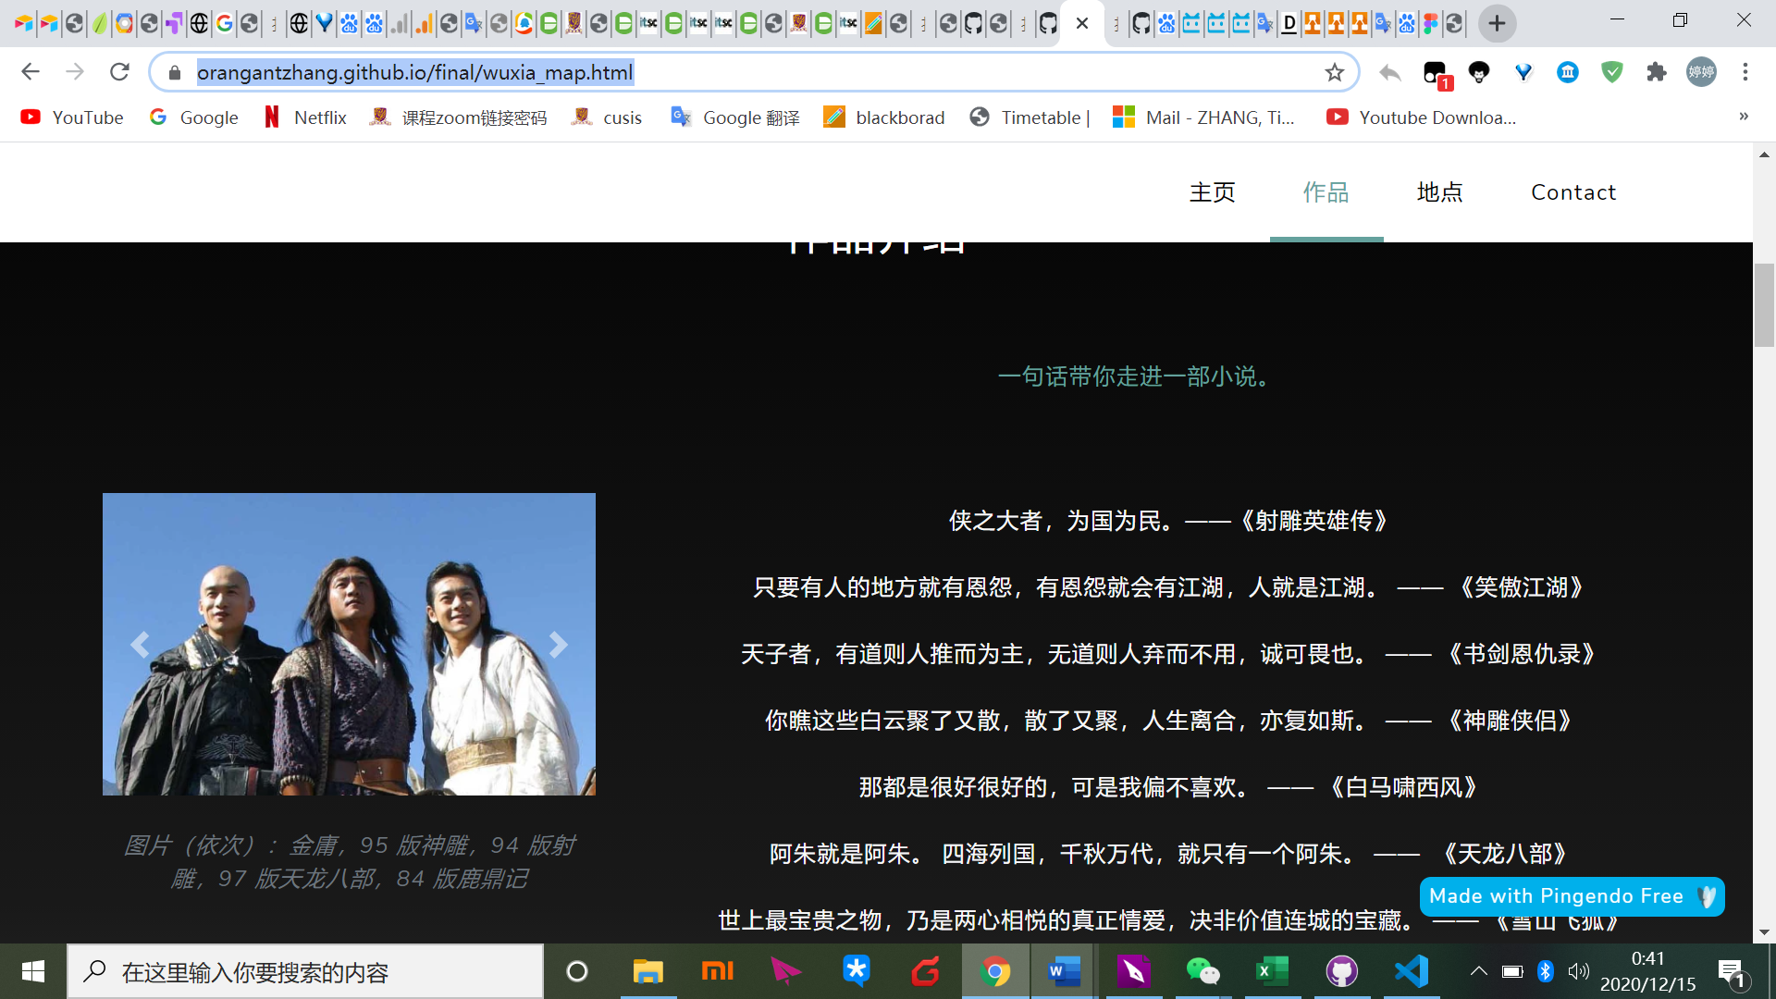

Homepage-introduction of works

1. Adding line chart formats

Previous ratings are in the airtable that users need to click for information. Now the line chart is straightforward for potential fans to quickly get basic information about quality of each novels.

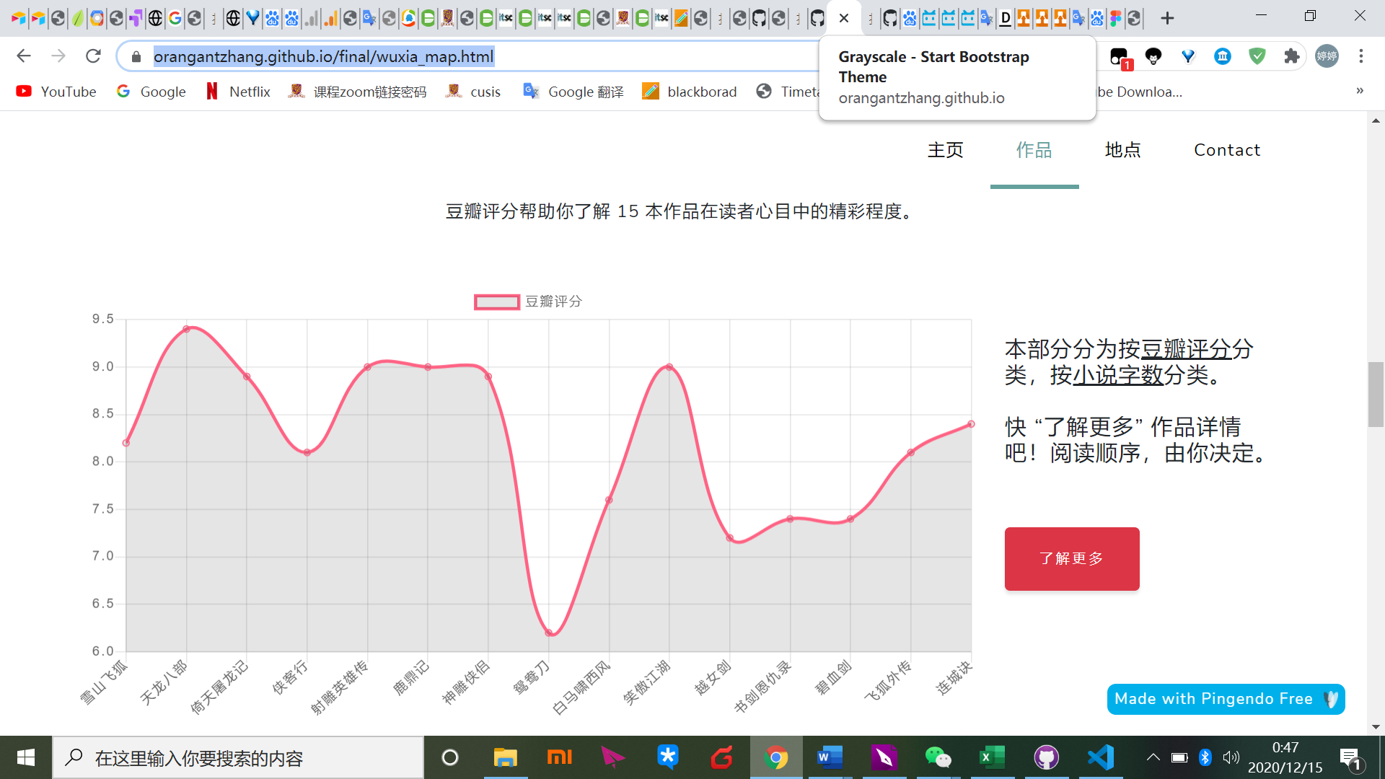

Homepage-novel work

1. Moving airtable of novels from homepage to the link page

Respondents think the previous homepage is not beautiful because of airtable. Furthermore, considering that potential fans may not have much patience to know about detailed introductions of works, I move the airtable to the link page. Also in the location part of homepage, I move the airtable in another link page.

In this page, at first users can find a line chart about comparison of word count of each novel. Alongside is the Douban rating which is useful for audiences deep learning next.

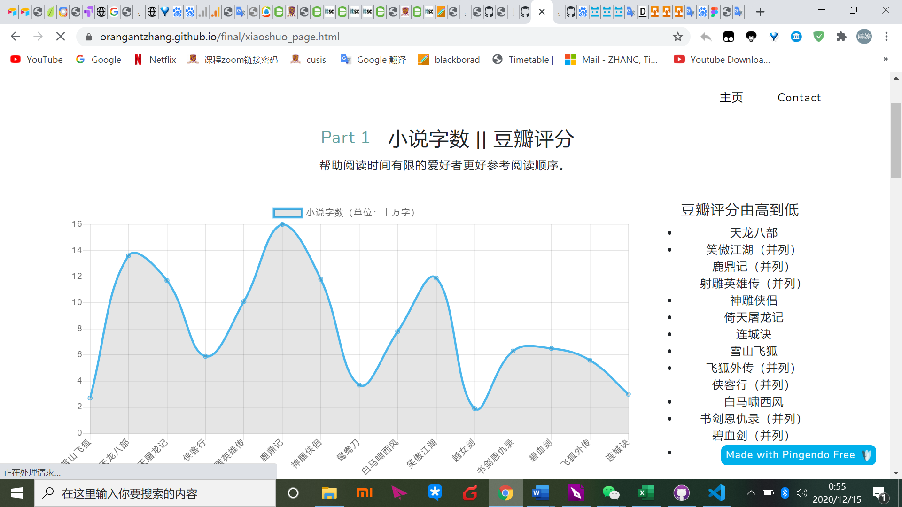

Novel work-detail page

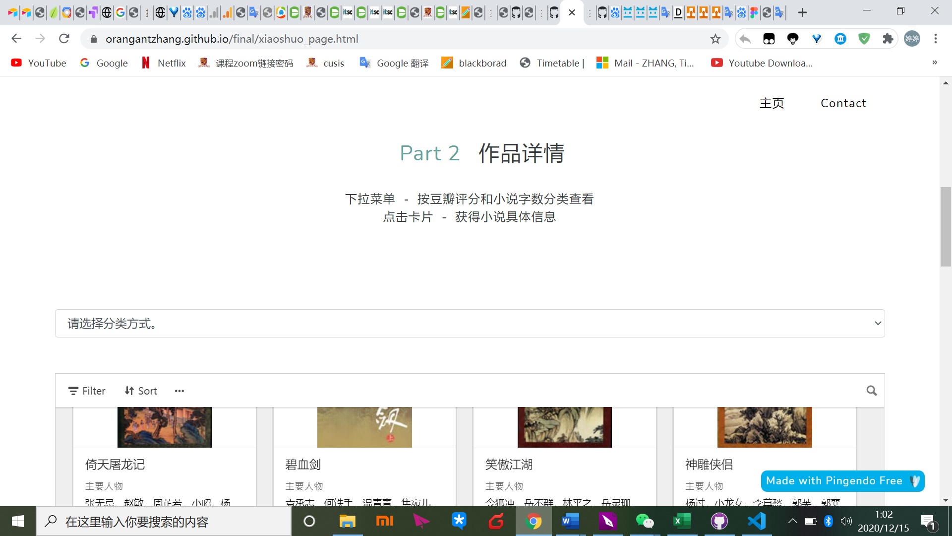

Novel work-detail page

1. Adding some description words

Previous website does not have clear description indications introducing the section feature or how to use some functions.

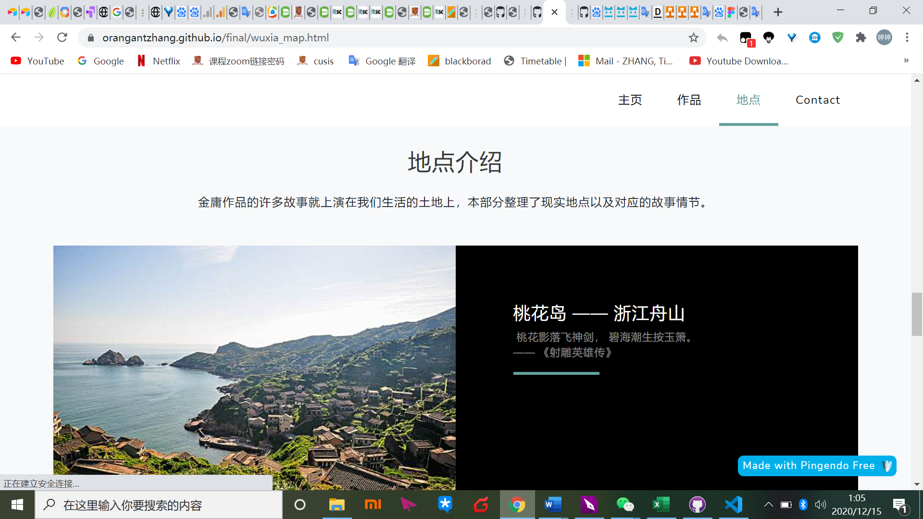

Homepage-location

1. Moving plots from airtable to the article form——redesign the location detailed information part

Respondents think the location and corresponding plots are more important than the tourism itself. The previous website puts plots in the airtatble that requires users to click and test users think it’s not user friendly. Considering that there are not many locations in each area, I can redesign detail information of each area in one single page and delete previous detailed page about ticket, local cuisine information. Respondents also think that many pictures of areas’ landscapes are not eye-catching compared with other areas therefore, in the new detailed page of each area, I do not use images of landscapes but use related character stills of the plot, which can also generate interests of potential fans because many characters in adapted series are famous celebrities nowadays.

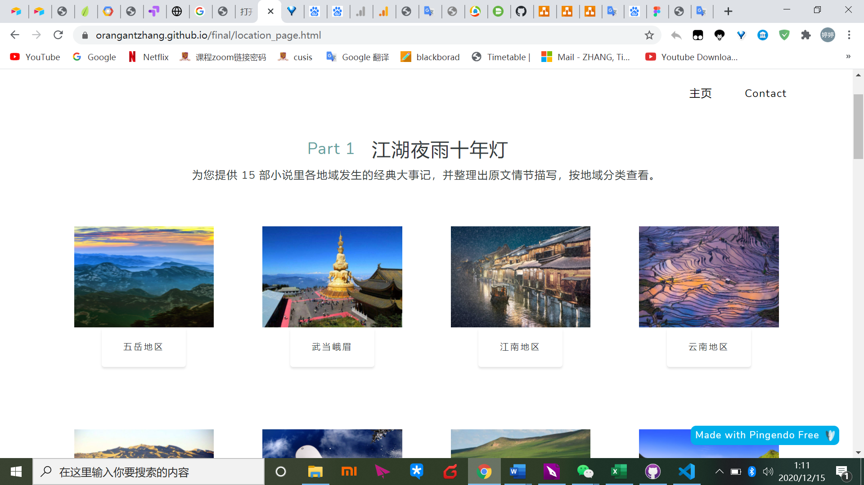

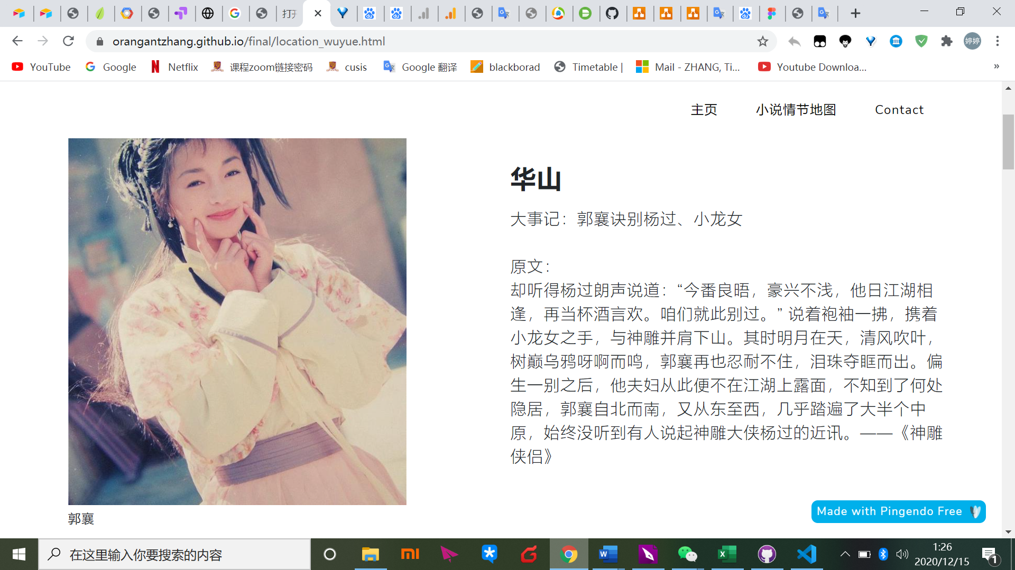

五岳地区link page

In this prototype step, the site has formed its final entity-relationship diagram and information architecture to date as follows.

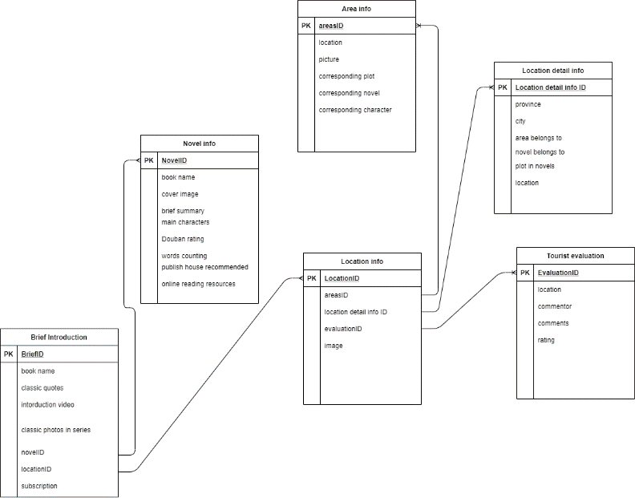

Entity-relationship Diagram

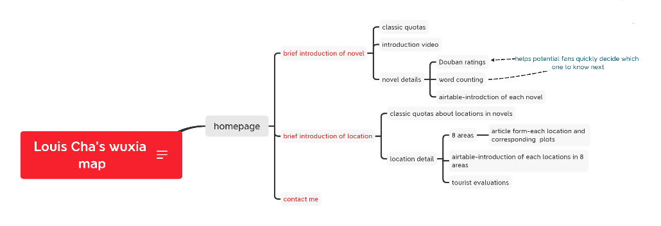

Information Architecture

* 1. A/B testing

In order to better explore whether the website content is attractive enough and meets the needs of the target users, an A/B testing is conducted with Google Analytics

and Google Optimize.

Specifically, the introduction of video is different in 2 editions. By comparing the data of the original version and variant 1, it can be found that the variant 1 performs better on bounce rate, that the introduction of video should be changed as variant 1 shows.



Original version

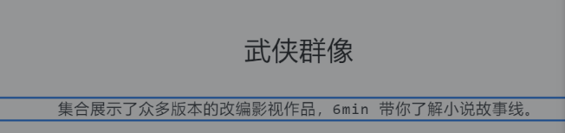

Variant 1

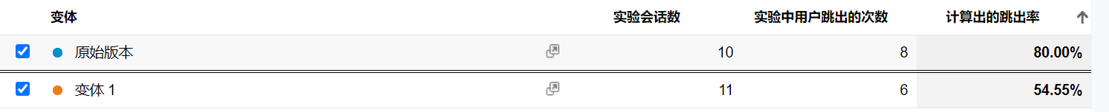

Data

* 1. Evaluation

For the basic information, it can be seen that to date, there are 24 users contributing 54page views. Number of sessions per user is 1.08 and pages/session is 1.03. Average session duration is 02:20. Bounce rate is 61.54%. Exit percentage is 48.15%. The overall samples are few, therefore data analysis may not be accurate.

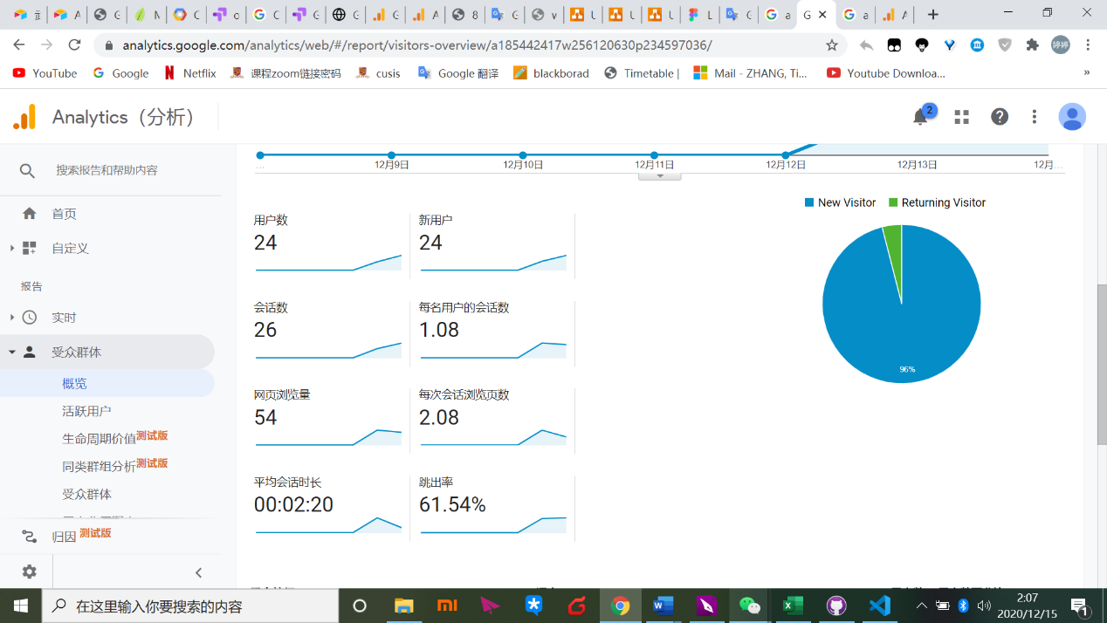

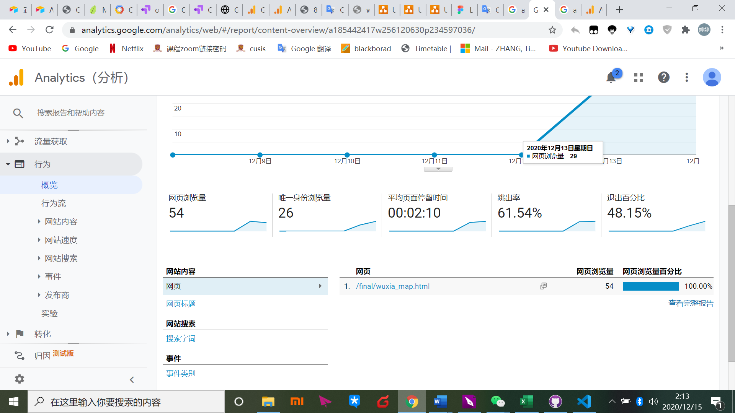

Overview

This website is promoting via WeChat groups and WeChat Moment. Audiences are from 3 areas——mainland China, Hong Kong and Taiwan. In mainland China, there are visitors from various cities like Beijing, Nanjing, Shanghai and so on.

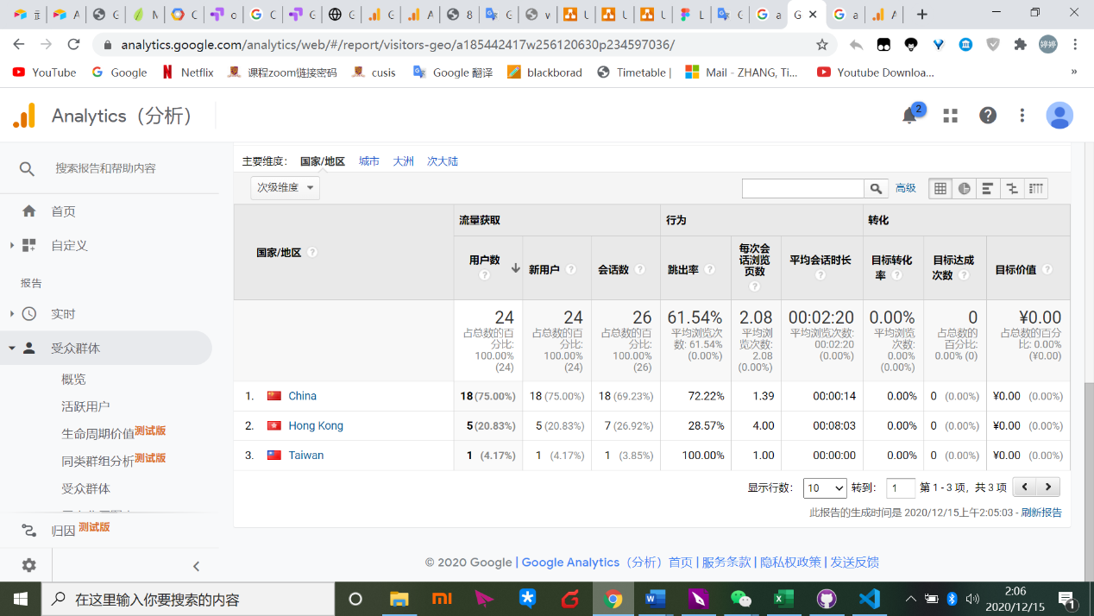

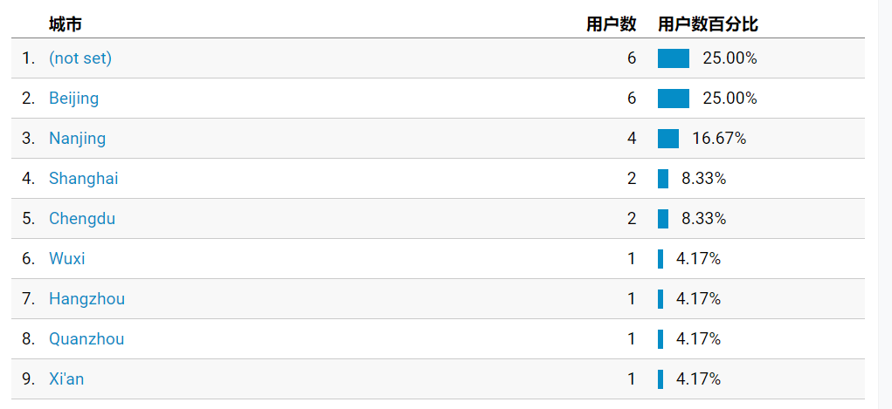

Locations

The website users are mainly using mobile devices, followed by computers. Therefore, for further development of the website, it needs adaption for the mobile version which may greatly improve user experience.

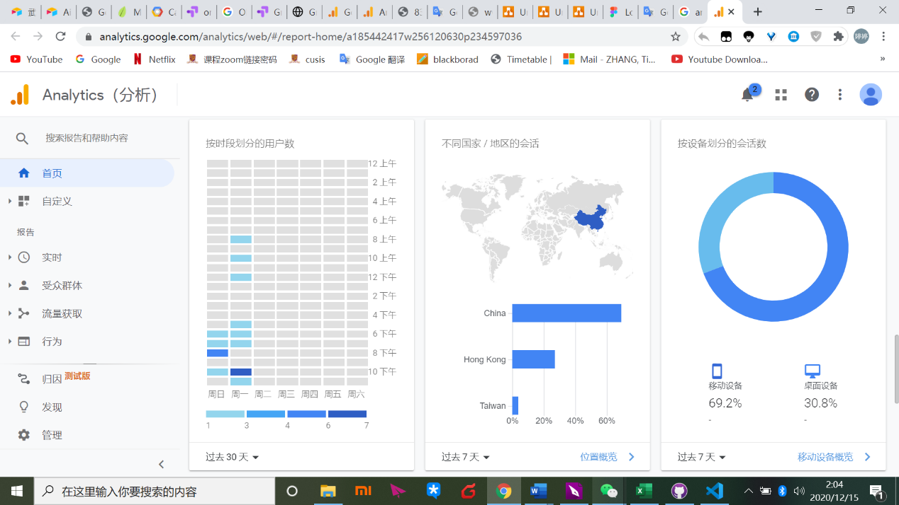

Device

1. Recommendations
   1. Operations

As objectives of the site, users may need professional feedbacks about Louis Cha’s relevant knowledge. Therefore, this site needs to provide answers either from contacting me that I have left my email on the website or using the community section of the site which need to be further improved. Data of locations can be updated.

* 1. Further development

Nowadays, the website has not obtained enough traffic and it needs more data from Google analytics to adjust some contents or layout. The current problem of the site is that it cannot adapt to mobile device that improving the mobile user experience and making the website functions and contents more suitable for mobile device.

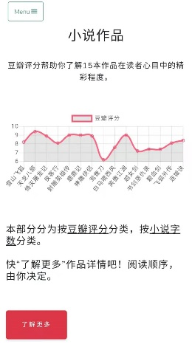

Current layout on mobile device

For the wuxia map section, it can provide a map illustrating geographical position of each area. Moreover, in the tourist evaluation section, these evaluations are too subjective which may not convince the audiences. The current evaluations are from mafengwo.com. But for my website, it needs updated evaluations which can provide users current information of these locations, beneficial to their travel decisions. Not only tourist evaluations, but also local people’s comments are important too. In the future, evaluation ratings are best presented with a single score combing both tourists’ and locals’ evaluations which can give users a straightforward and real acknowledgement about these locations.

* 1. Business Case

The website is more like a knowledge site. From the knowledge perspective, it may attract PGC (Professionally-produced Content) and setting up business model that users if want to know more professional knowledge they should pay for PGC. And my website can get share from professional bloggers.

From the wuxia map perspective, nowadays, many people have travelling need. For target audience of my website, they may generate interests in these locations. There is a common phenomenon that many people prefer to know about local celebrity stories, historical legends when traveling. This website can provide more classic information about these places which can attract traffic and even advertisement resources.

Nowadays, many Chinese less-developed areas like some western cities are vigorously developing tourism resources. However, because of lacking popularity on the internet, and also some problems of current travel websites like Alitrip.com that assign too much content resources on popular tourist cities, these western cities can not obtain many impressions. In Louis Cha’s wuxia works, many plots happened in these less-development areas like western cities or Yunnan province. My website can give some exposures for these areas, earning traffic and cooperate with ticket platforms like alitrip.com and may even sell tickets of local viewpoints.

According to introducing these tourism places, this site can cooperate with famous travel vloggers of social media platform so that they can endorse this website and play a role in increasing the website’s traffic.